**PRODUCT**

PRODUCT DESIGN

**Compatible Browsers:** [IE9](http://themeforest.net/attributes/compatible-browsers/IE9), [IE10](http://themeforest.net/attributes/compatible-browsers/IE10), [IE11](http://themeforest.net/attributes/compatible-browsers/IE11), [Firefox](http://themeforest.net/attributes/compatible-browsers/Firefox),[Safari](http://themeforest.net/attributes/compatible-browsers/Safari), [Opera](http://themeforest.net/attributes/compatible-browsers/Opera), [Chrome](http://themeforest.net/attributes/compatible-browsers/Chrome).

**Layout:** Full responsive.

**Design tools:** jQuery, Caroufredsel, BXSlider, MeanMenu, jQuery Parallax, jQuery Easing, PrettyPhoto, Tabs, Tiptip, modernizr-2.6.2, Font Awesome , Ions, Colorbox

**Validation:** SuccessfulW3C validation for html, css, javascript.

Step by step description are mention bellow

**1. Folder Structure**

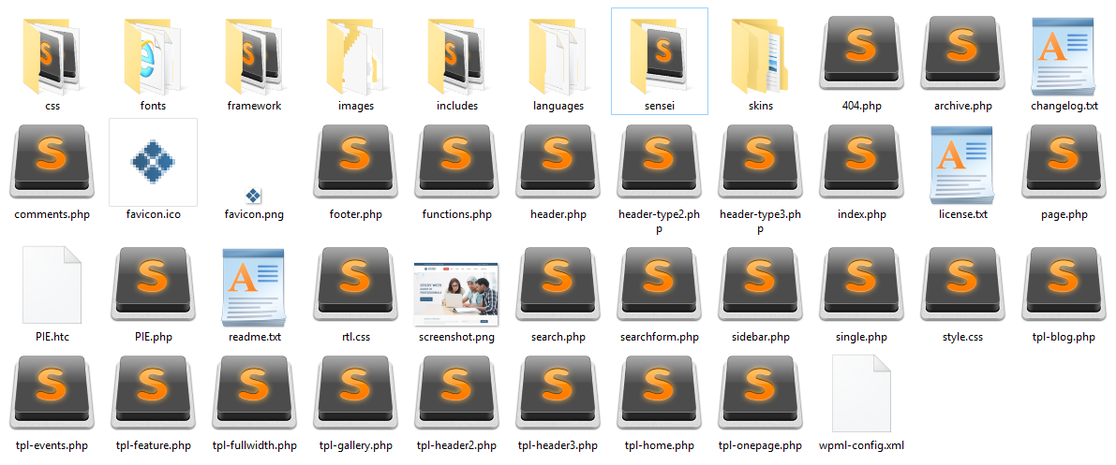

1. style.css - The Main style.css
2. The css folder - contains the CSS for all major browsers, font awesome and responsive to make the site responsive for all devices (Please ensure that your new styles are applied. Also make sure that they carry enough "weight" and there isn't a style lower in the CSS file that is being applied after yours.)
3. The framework folder - contains all the theme functions and admin options to the better use of theme.
4. The images folder - contains all the images that are being used in the stylesheets for the layout purpose and it has a subfolder named patterns, prettyphoto, colorbox which contains images used in corresponding stylesheets.
5. The includes folder - contains the theme support include files.
6. The languages folder - contains default.po and default.mo language files to be used for multi-language purpose.
7. The skins folder - contains the CSS for only one predefined color skins that comes along with this theme.
8. The framework \ js \ public folder - contains javascript files and plugins as follows,
9. ContactForm jquery for validation(contact.js, jquery.validate.min.js)
10. AnimateNumber jquery for auto running numbers(jquery.animateNumber.min.js)
11. BXSlider plugin for slider animation (jquery.bxslider.js)
12. CarouFredSel plugin for testimonials (jquery.carouFredSel-6.2.0-packed.js)
13. Donutchart plugin for progressbar animation (jquery.donutchart.js)
14. FitVids for Fit video to container width (jquery.fitvids)
15. Inview plugin for animation purpose (jquery.inview.js)
16. Isotope plugin for filter gallery (jquery.isotope.min.js)
17. MeanMenu plugin for responsive menu (jquery.meanmenu.js)
18. Nav jquery plugin for one page navigation(jquery.nav.js)
19. Parallax plugin for background parallax animation (jquery.parallax-1.1.3.js)
20. PrettyPhoto plugin for image preview animation (jquery.prettyPhoto.js)
21. Scrolls (jquery.nicescroll.min.js, jquery.scrollTo.js)
22. SmartResize plugin for resizing module at responsive (jquery.smartresize.js)
23. Sticky plugin for sticky navigation (jquery.sticky.js)
24. UITOTop plugin for Goto Top animation (jquery.ui.totop.min.js)
25. Skin Chooser plugin (controlpanel.js, jquery.cookie.js)
26. And custom js like (custom.js)

2. HTML **Structure**

Here is the HTML Structure of the Theme (simplified):

<div class="main-content">

<!-- **Wrapper** -->

<div class="wrapper">

<!-- **Top Bar** -->

<div class="top-bar">

<div class="container">

<div class="float-left"></div>

<div class="float-right"></div>

</div>

</div><!-- **Top Bar End** -->

<!-- **Header Wrapper** -->

<div id="header-wrapper">

<header>

<div class="menu-main-menu-container header1">

<div class="container">

<div id="logo"></div>

<div id="primary-menu">

<nav id="main-menu"></nav>

</div>

</div>

</div>

</header>

</div><!-- **Header Wrapper End** -->

<section class="breadcrumb-wrapper">

<div class="container">

<h1><cufon class="cufon cufon-canvas" alt=". " style="width: 21px; height: 30px;"><canvas width="44" height="31" style="width: 44px; height: 31px; top: -3px; left: -2px;"></canvas><cufontext>. </cufontext></cufon><cufon class="cufon cufon-canvas" alt=". " style="width: 21px; height: 30px;"><canvas width="44" height="31" style="width: 44px; height: 31px; top: -3px; left: -2px;"></canvas><cufontext>. </cufontext></cufon><cufon class="cufon cufon-canvas" alt="." style="width: 11px; height: 30px;"><canvas width="34" height="31" style="width: 34px; height: 31px; top: -3px; left: -2px;"></canvas><cufontext>.</cufontext></cufon></h1>

</div>

</section>

<!-- **Content Starts** -->

<div class="content">

<div class="container">

<section class="with-left-sidebar" id="primary">. . .</section>

<section class="left-sidebar" id="secondary">. . .</section>

</div>

</div><!-- **Content Ends** -->

<!-- **Footer** -->

<footer id="footer">

<div class="footer-top-links">

<div class="container">. . .</div>

</div>

<div class="footer-widgets">

<div class="container">. . .</div>

</div>

<div class="footer-info">

<div class="container"><p class="copyright">. . .</p></div>

</div>

</footer><!-- **Footer End** -->

</div><!-- **Wrapper End** -->

</div>

**3. Css file & structure**

The style.css is main css file used in this theme. This file contains some general styling such as anchor tag colors, font-sizes & etc. Keep in mind that these values might be overridden somewhere else in the file.

@charset "UTF-8";

/* CSS Document */

@import "css/reset.css";

/*----*****---- << General >> ----*****----*/

body styles comes here

/*----*****---- << Fonts >> ----*****----*/

Fonts styles comes here

/*----*****---- << Bordered Title >> ----*****----*/

Bordered title styles comes here

/*----*****---- << Border Radius >> ----*****----*/

Bordered radius styles comes here

/*----*****---- << Headings >> ----*****----*/

Headings styles comes here

/*----*****---- << Transition >> ----*****----*/

Transition styles comes here

/*----*****---- << Text Elements >> ----*****----*/

Text Elements styles comes here

/*----*****---- << Tables >> ----*****----*/

Tables styles comes here

/*----*****---- << Definition Lists >> ----*****----*/

Definition Lists styles comes here

/*----*****---- << Forms >> ----*****----*/

Forms styles comes here

/*----*****---- << Images >> ----*****----*/

Images styles comes here

/*----*****---- << Widgets >> ----*****----*/

Widgets styles comes here

/*----*****---- << Boxed >> ----*****----*/

Boxed styles comes here

/*----*****---- << Header >> ----*****----*/

Header styles comes here

/*----*****---- << Main Menu >> ----*****----*/

Main Menu styles comes here

/*----*****---- << Footer >> ----*****----*/

Footer styles comes here

....

If you would like to edit a specific section of the site, simply find the appropriate label in the CSS file, and then scroll down until you find the appropriate style that needs to be edited.

4. Javascript

This theme imports the following Javascript files.

1. ContactForm jquery for validation(contact.js, jquery.validate.min.js)

2. AnimateNumber jquery for auto running numbers(jquery.animateNumber.min.js)

3. BXSlider plugin for slider animation (jquery.bxslider.js)

4. CarouFredSel plugin for testimonials (jquery.carouFredSel-6.2.0-packed.js)

5. Donutchart plugin for progressbar animation (jquery.donutchart.js)

6. FitVids for Fit video to container width (jquery.fitvids)

7. Inview plugin for animation purpose (jquery.inview.js)

8. Isotope plugin for filter gallery (jquery.isotope.min.js)

9. MeanMenu plugin for responsive menu (jquery.meanmenu.js)

10. Nav jquery plugin for one page navigation(jquery.nav.js)

11. Parallax plugin for background parallax animation (jquery.parallax-1.1.3.js)

12. PrettyPhoto plugin for image preview animation (jquery.prettyPhoto.js)

13. Scrolls (jquery.nicescroll.min.js, jquery.scrollTo.js)

14. SmartResize plugin for resizing module at responsive (jquery.smartresize.js)

15. Sticky plugin for sticky navigation (jquery.sticky.js)

16. UITOTop plugin for Goto Top animation (jquery.ui.totop.min.js)

17. Skin Chooser plugin (controlpanel.js, jquery.cookie.js)

18. And custom js like (custom.js)

**5. Source & Credits**

Thanks a lot to

1. jQuery
2. Caroufredsel
3. BXSlider
4. MeanMenu
5. jQuery Parallax
6. jQuery Easing
7. PrettyPhoto
8. Tabs
9. Tiptip
10. modernizr-2.6.2
11. Font Awesome Icons
12. Colorbox

Once again, thank you so much for purchasing this theme. As I said at the beginning, We'll be glad to help you if you have any questions relating to this theme. No guarantees, but I'll do my best to assist. If you have a more general question relating to the themes on ThemeForest, you might consider visiting our forums to ask your question in the "Item Discussion" section.

Product Development

**PHP version:** php 4.4.43

**Wordpress version:** wordpress 4.4.2

**Apache version:** Apache 2.4.12

**File structure**

Theme files



Plugins files

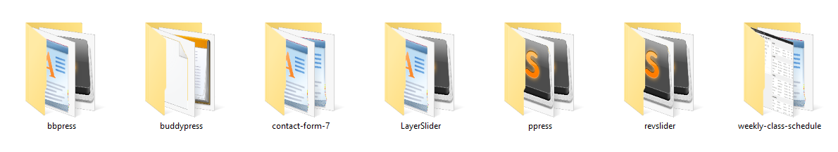

**Theme development**

1. style.css

The main style sheet. This must be included with your Theme, and it must contain the information header for your Theme.

1. rtl.css

The rtl style sheet. This will be included automatically if the website's text direction is right-to-left. This can be generated using the RTLer plugin.

1. index.php

The main template. If your Theme provides its own templates, index.php must be present.

1. comments.php

The comments template.

1. front-page.php

The front page template.

1. home.php

The home page template, which is the front page by default. If you use a static front page this is the template for the page with the latest posts.

1. single.php

The single post template. Used when a single post is queried. For this and all other query templates, index.php is used if the query template is not present.

1. single-{post-type}.php

The single post template used when a single post from a custom post type is queried. For example, single-book.php would be used for displaying single posts from the custom post type named "book". index.php is used if the query template for the custom post type is not present.

1. page.php

The page template. Used when an individual Page is queried.

1. category.php

The category template. Used when a category is queried.

tag.php

The tag template. Used when a tag is queried.

1. taxonomy.php

The term template. Used when a term in a custom taxonomy is queried.

1. author.php

The author template. Used when an author is queried.

1. date.php

The date/time template. Used when a date or time is queried. Year, month, day, hour, minute, second.

1. archive.php

The archive template. Used when a category, author, or date is queried. Note that this template will be overridden by category.php, author.php, and date.php for their respective query types.

1. search.php

The search results template. Used when a search is performed.

1. attachment.php

Attachment template. Used when viewing a single attachment.

1. image.php

Image attachment template. Used when viewing a single image attachment. If not present, attachment.php will be used.

1. 404.php

The 404 Not Found template. Used when WordPress cannot find a post or page that matches the query.

Product User Guide

1. **Home page**
   * 1. How to change top left text?
     2. How to Login, register?
     3. How to view, edit user profile?
     4. How to change Logo?
     5. How to create Page?
     6. How to add Menu?
     7. How to add new slider?
     8. How to add or edit features?
     9. How to add team or teachers?
     10. How to add or edit skill counter?
     11. How to add or edit home page tab?
     12. How to add footer top menu?
     13. How to change footer bottom text?
     14. How to change footer right menu?
2. **Timetable page**
3. How to add/edit/delete Classes?
4. How to add/edit/delete Instructor?
5. How to add/edit/delete Location?
6. How to make a final schedule?
7. **About page**
8. **Contact page**

Answers

**1. Home page**

**a) How to change top left text**

Go to **Dashboard** > **Guru** > **General** > **Top** and change ***Top Left Content***

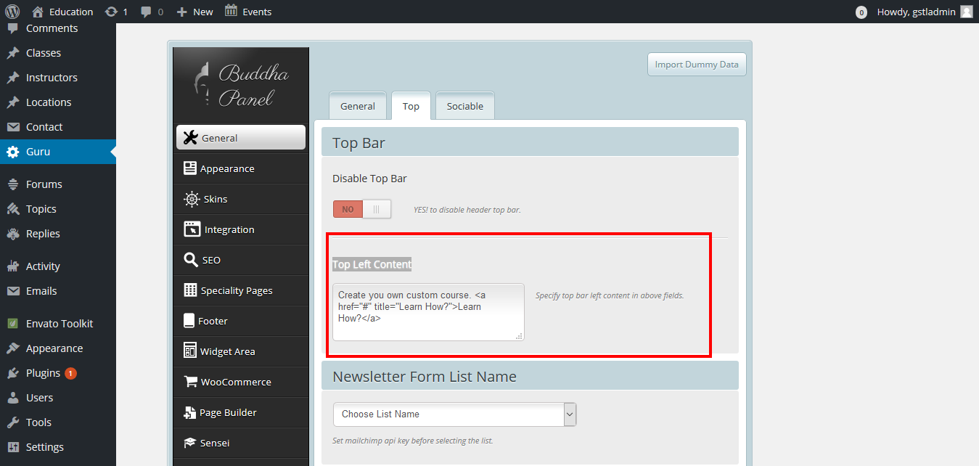

**b) How to Login, register**

For registration just click right to **register** button then appear register page

Fill all required field and click complete signup then an activation message will go to your email after activation you can login this site

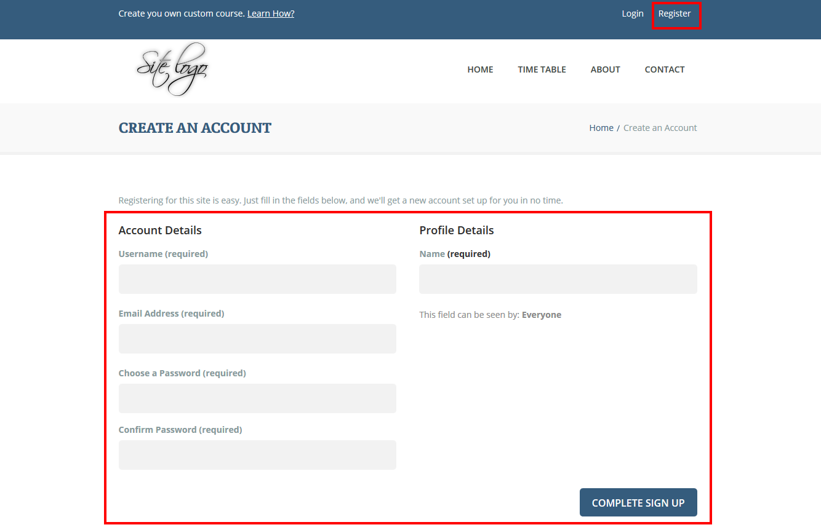

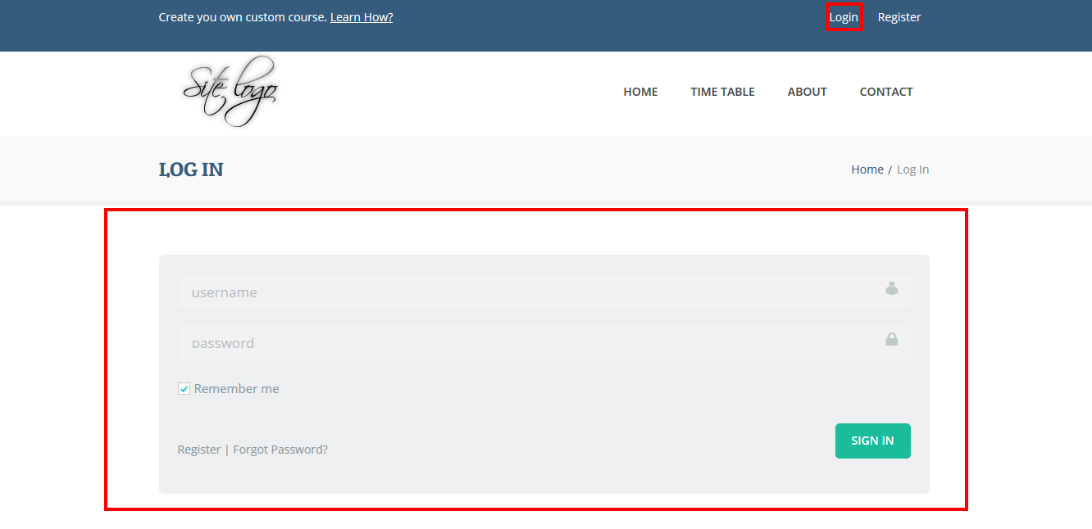

**c) How to view, edit user profile**

After login you can see right top menu changes from **login**, **register** to **profile**, **logout**. Click **profile** to see your profile. There are Edit button in Profile tab. User can edit there profile information from here.

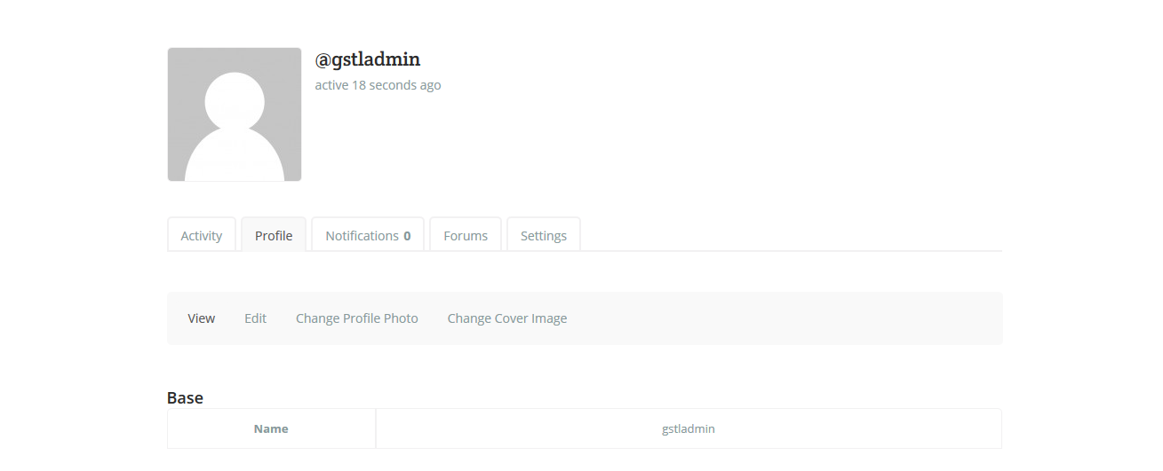

**d) How to change Logo**

Go to **Dashboard** > **Guru** > **General** and upload a logo and save

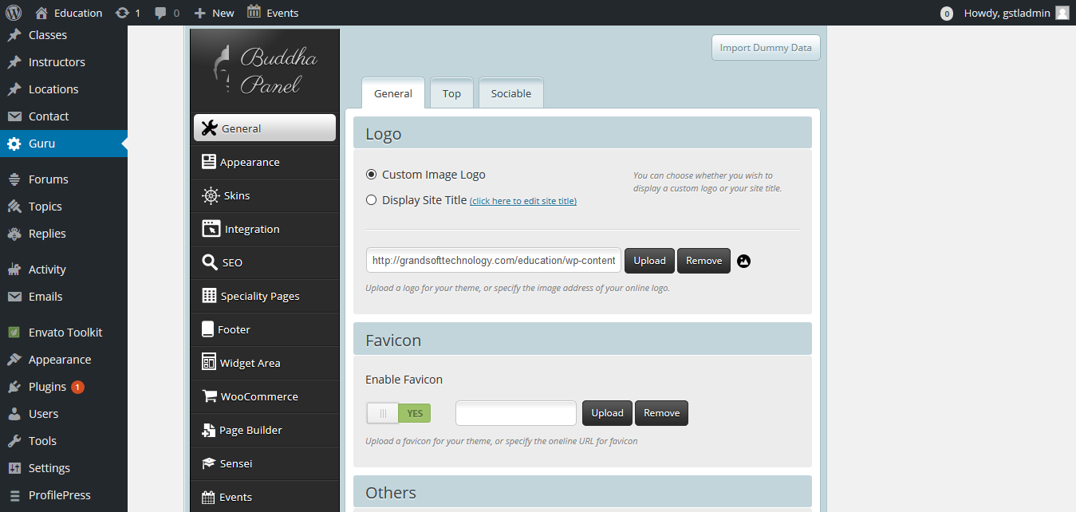

**e) How to create Page**

This site already have many pages if you want a new then go to **Dashboard** > **Pages**> **add new**

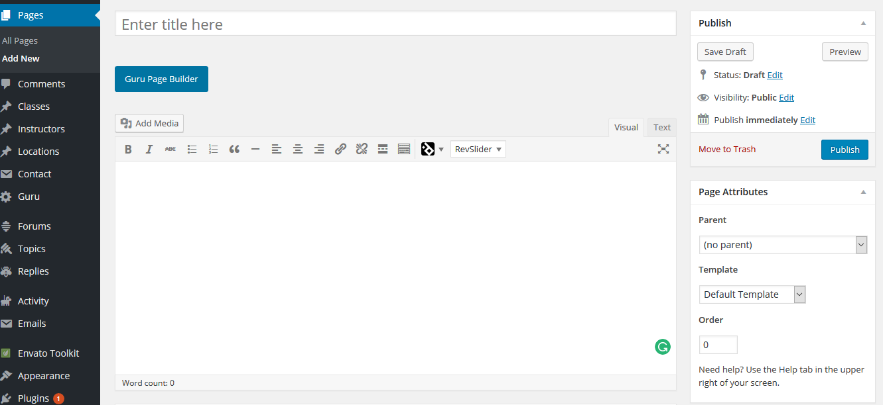

**f) How to add Menu**

Go to **Dashboard** > **Appearance** > **menus** > select menu. For top menu select **Main menu**. Then add new menu and save.

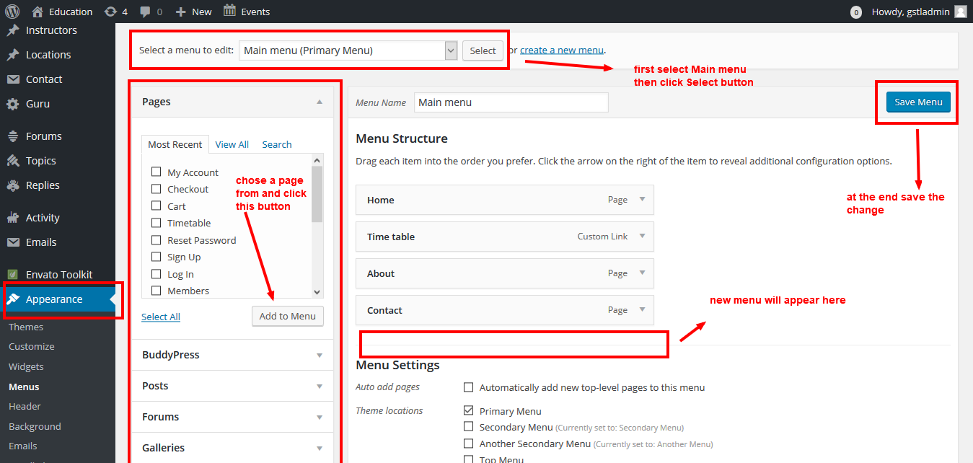

**g) How to add new slider**

Go to **Dashboard** > **Revolution slider** > **edit slider**

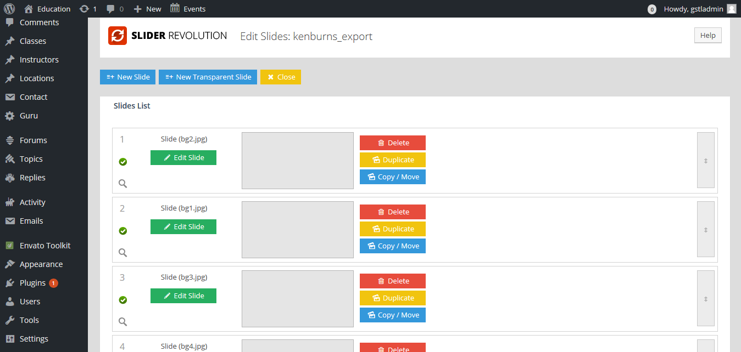

Video tutorial link: https://www.youtube.com/watch?v=p7rBZmYgfUU

**h) How to add or edit features**

**I) How to add team or teachers**

**j) How to add or edit skill counter**

**k) How to add or edit home page tab**

For above 4 need to go **Dashboard** > **All pages** > **Home** edit here you can see some short code. For clear understanding study about short code that mention bellow

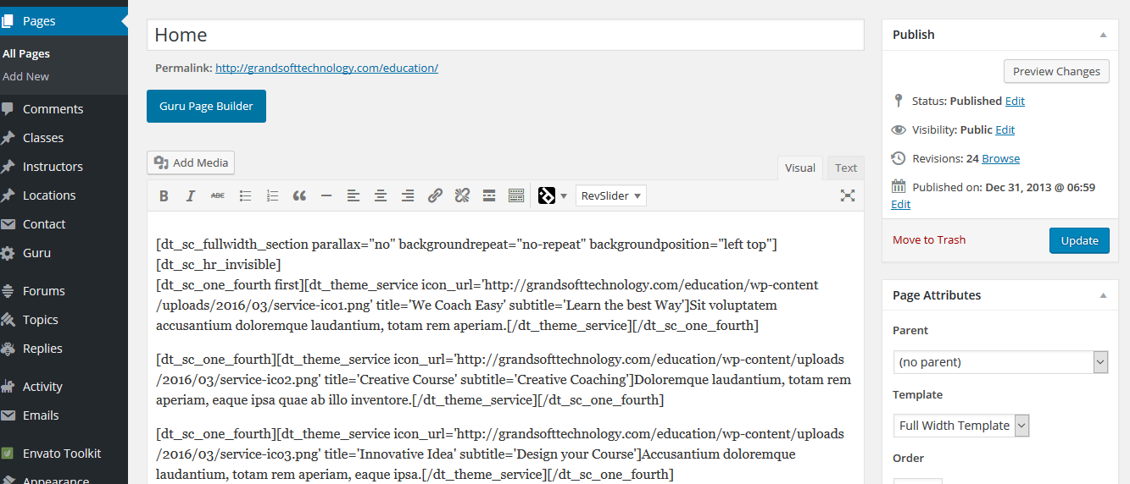

**Short code**

* Vertical Tabs - [dt_sc_tabs_vertical][dt_sc_tab title="Tab 1"] Put Your Content [/dt_sc_tab][dt_sc_tab title="Tab 2"] Put Your Content   
  [/dt_sc_tab][/dt_sc_tabs_vertical]
* Horizontal Tabs -

[dt_sc_tabs_horizontal][dt_sc_tab title="Tab 1"] Put Your Content [/dt_sc_tab][dt_sc_tab title="Tab 2"] Put Your Content [/dt_sc_tab][/dt_sc_tabs_horizontal]

* Frameless Tabs -

[dt_sc_tabs_horizontal_frame_less][dt_sc_tab title="Tab 1"] Put Your Content [/dt_sc_tab][dt_sc_tab title="Tab 2"] Put Your Content [/dt_sc_tab][/dt_sc_tabs_horizontal_frame_less]

* Standard Accordion -

[dt_sc_accordion_group][dt_sc_toggle title="What is Lorem Ipsum?"] Put Your Content [/dt_sc_toggle][dt_sc_toggle title="Where does it come from?"] Put Your Content [/dt_sc_toggle][/dt_sc_accordion_group]

* Framed Accordion -

[dt_sc_accordion_group][dt_sc_toggle_framed title="Tab 1"] Put Your Content [/dt_sc_toggle_framed][dt_sc_toggle_framed title="Tab 2"] Put Your Content[/dt_sc_toggle_framed][/dt_sc_accordion_group]

* Standard Toggle -

[dt_sc_accordion_group][dt_sc_toggle_framed title="Tab 1"] Put Your Content [/dt_sc_toggle_framed][dt_sc_toggle_framed title="Tab 2"] Put Your Content [/dt_sc_toggle_framed][/dt_sc_accordion_group]

* Framed Toggle -

[dt_sc_accordion_group][dt_sc_toggle title="Tab1"] Put Your Content [/dt_sc_toggle][dt_sc_toggle title="Tab2"] Put Your Content [/dt_sc_toggle][/dt_sc_accordion_group]

* Small Button -

[dt_sc_button size="small" variation="red" align="left" target="_blank"]Small Button[/dt_sc_button]

* Medium Button -

[dt_sc_button size="medium" variation="red" align="left" target="_blank"]Medium Button[/dt_sc_button]

* Large Button -

[dt_sc_button size="large" variation="red" align="left" target="_blank"]Large Button[/dt_sc_button]

* XLarge Button -

[dt_sc_button size="xlarge" variation="red" align="left" target="_blank"]XLarge Button[/dt_sc_button]

* Fancy Titled Boxes -

[dt_sc_box type="titled-box" title="Titled Box" variation="blue" textcolor="#ffffff"] Put Your Content [/dt_sc_box]

* Pricing Table -

[dt_sc_pricing_table type =" type1"] [dt_sc_pricing_table_item heading='' button_text='' button_link='#' price='' per='' selected] <ul> <li>Text</li> <li>Text</li> </ul> [/dt_sc_pricing_table_item] [/dt_sc_pricing_table]

* Pricing Table - II

[dt_sc_pricing_table type =" type1"] [dt_sc_pricing_table_item heading='' button_text='' button_link='#' price='' per='' selected] [dt_pricing_round_text heading='Some Heading' midtitle='Some Text' text='Some Content'/] [/dt_sc_pricing_table_item] [/dt_sc_pricing_table]

* Blockquotes -

[dt_sc_blockquote variation="green"] Put Your Content [/dt_sc_blockquote]

* Pullquotes -

[dt_sc_pullquote type="pullquote3" icon="yes" align="center"] Put Your Content [/dt_sc_pullquote]

* Progress Bars -

[dt_sc_progressbar value='90' type='standard' color='#7aa127'] Put Your Content[/dt_sc_progressbar]

[dt_sc_progressbar value='90' type='progress-striped' color='#e67fb9'] Put Your Content[/dt_sc_progressbar]

[dt_sc_progressbar value='90' type='progress-striped-active' color='#a23b6f'] Put Your Content[/dt_sc_progressbar]

* ToolTip -

[dt_sc_tooltip type="left" bgcolor="#dd9933" textcolor="#000000" text="ToolTip Content" href="#"]ToolTip in Left[/dt_sc_tooltip]

* Team -

[dt_sc_team limit="4" columns="4" role="yes" /]

* Ordered Lists -

[dt_sc_fancy_ol style="lower-roman"] <ol> <li>List Item 1</li> <li>List Item 2</li> </ol>[/dt_sc_fancy_ol]

* Unordered Lists -

[dt_sc_fancy_ul style="rounded-plus" variation="cyan"] <ul> <li>List Item 1</li> <li>List Item 2</li> </ul> [/dt_sc_fancy_ul]

* Dividers -

[dt_sc_hr] , [dt_sc_hr_medium] , [dt_sc_hr_large] , [dt_sc_hr top] , [dt_sc_hr_invisible] , [dt_sc_hr_invisible_medium] , [dt_sc_hr_invisible_large], [dt_margin value="10" /]

* Testimonials -

[dt_sc_testimonial name="Lorem" role="Chairman" image=""]Put Your Content[/dt_sc_testimonial]

**l) How to add footer top menu**



Go to **Dashboard** >**Appearance**> **menus** select another secondary menu and edit

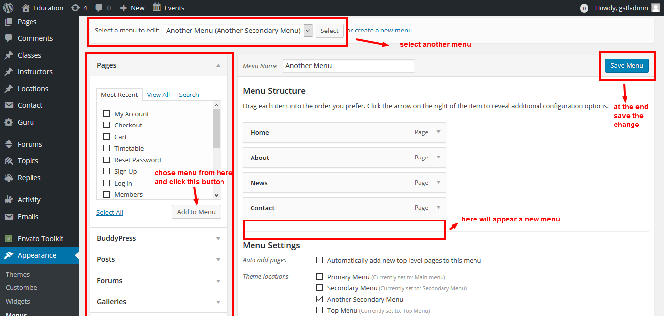

**m) How to change footer bottom text**

Go to **Dashboard** >**Guru** >**footer** scroll bottom and change the text

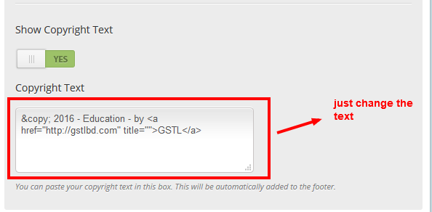

**n) How to change footer right menu**

Go to **Appearance** > **Menus** Select menu named secondary menu then check page and click **add to menu** button then click **save menu** button.

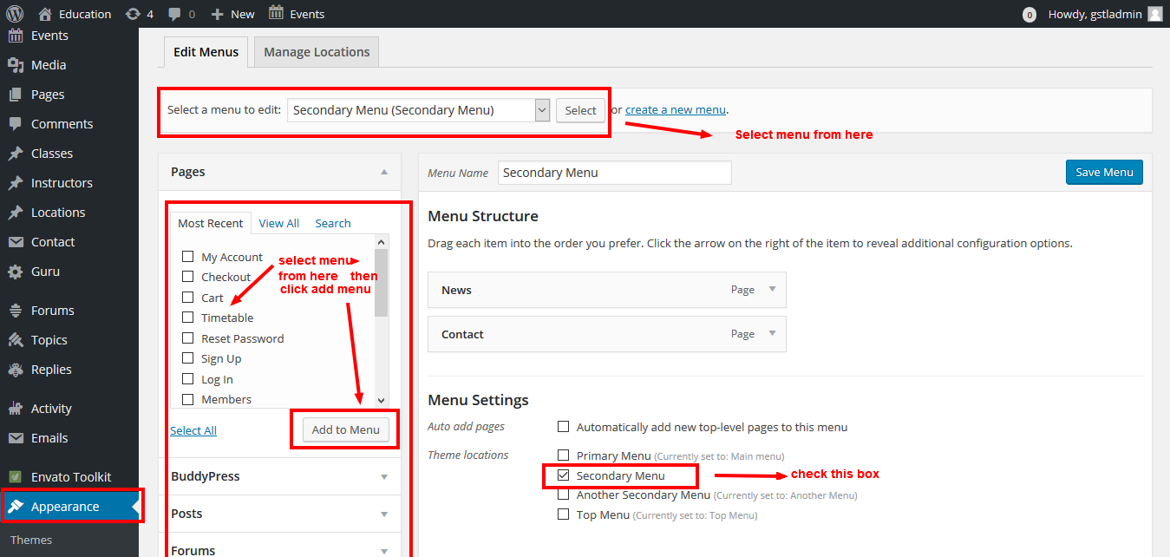

**2. TimeTable page**

**a) How to add/edit/delete Classes**

Go to **Dashboard** > **Classes** here all class lists displayed

For add new class click **Add new** button then fill class name and description and publish

There are **edit** and **delete** button on each list item so you can edit and delete class from here

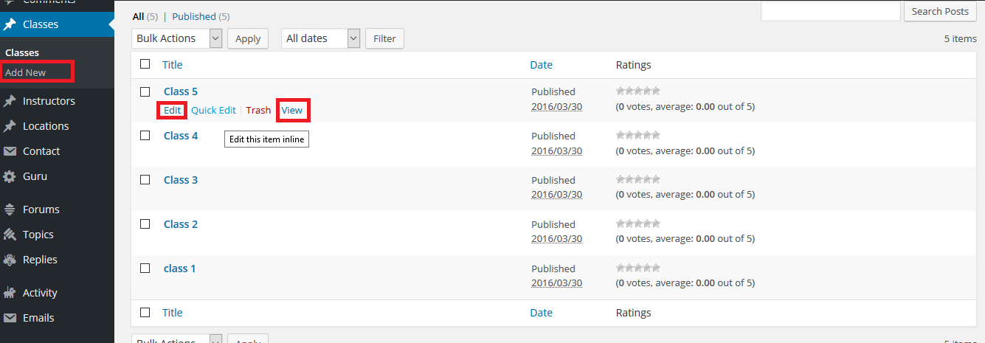

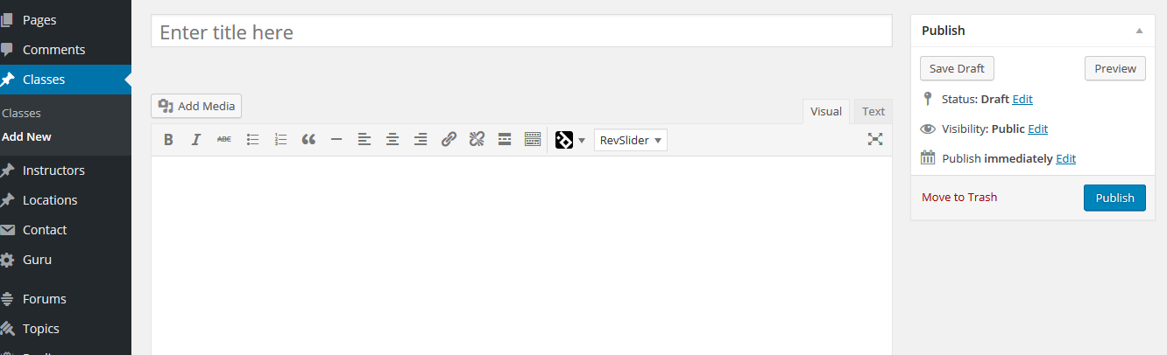

**b) How to add/edit/delete Instructor**

Go to **Dashboard** > **Instructor** here you can see all Instructor list. For add new **Instructor** click **Add new** button and fill Instructor credential.

There are **edit** and **delete** button on each list item so you can edit and delete Instructor from here

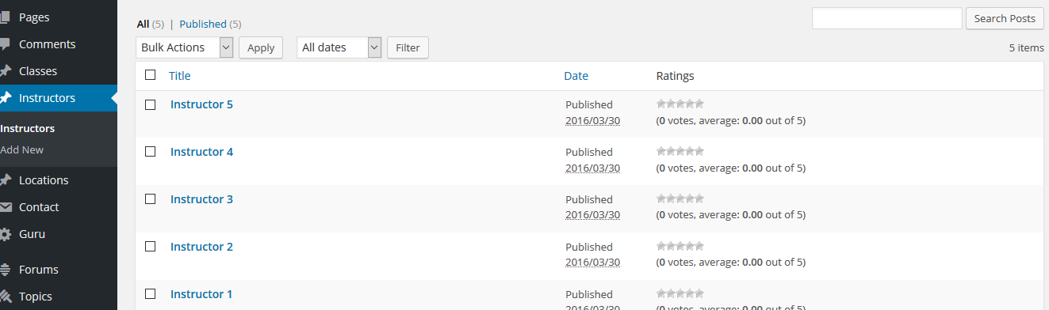

**C) How to add/edit/delete Location**

Go to **Dashboard** > **Location** here you can see all Instructor list. For add new Location click **Add new** button and fill Location credential.

There are **edit** and delete **button** on each list item so you can edit and delete Location from here

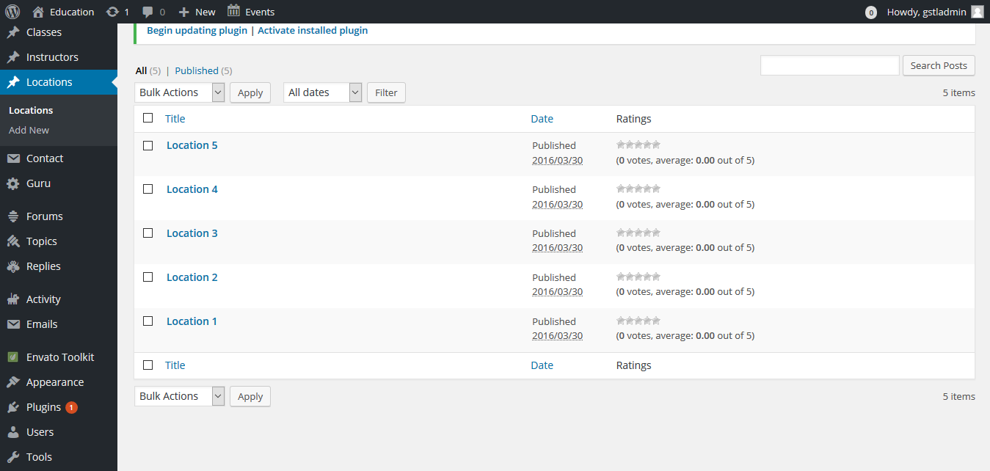

**D) How to make a final schedule**

Go to **Dashboard** > **schedule**

First select a **class** that you entered before then select a **instructor**, **location** .Then enter **start** **hour** , **end** **hour** , **visibility** , **note**

Then automatically class is added on timetable page

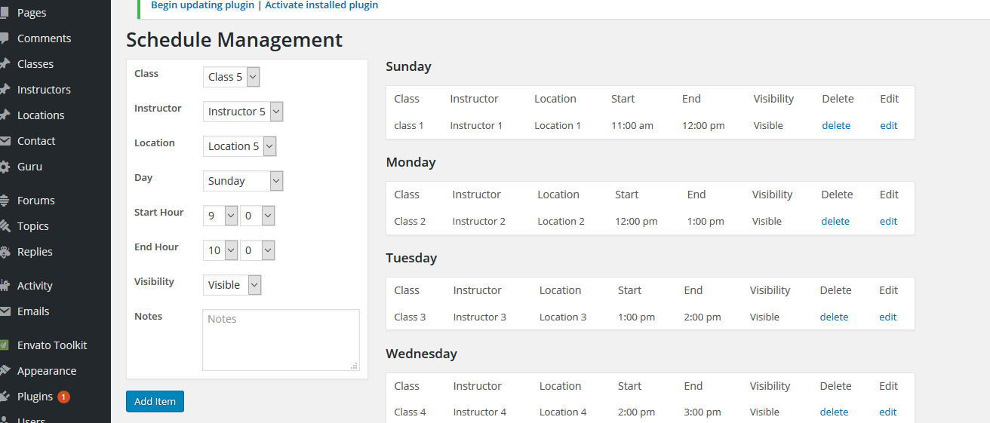

**3. About page**

Go to **Dashboard** > **pages** > **about** edit page. Here you will see some shortcode

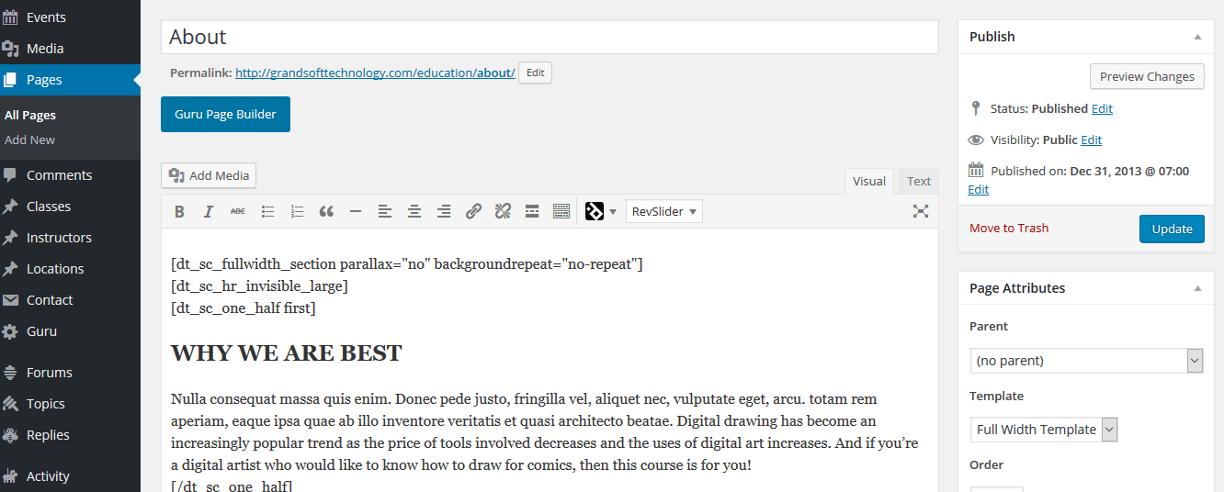

**4. Contact page**

Go to **Dashboard** > **pages** > **contact** edit page. Here you will see some shortcode

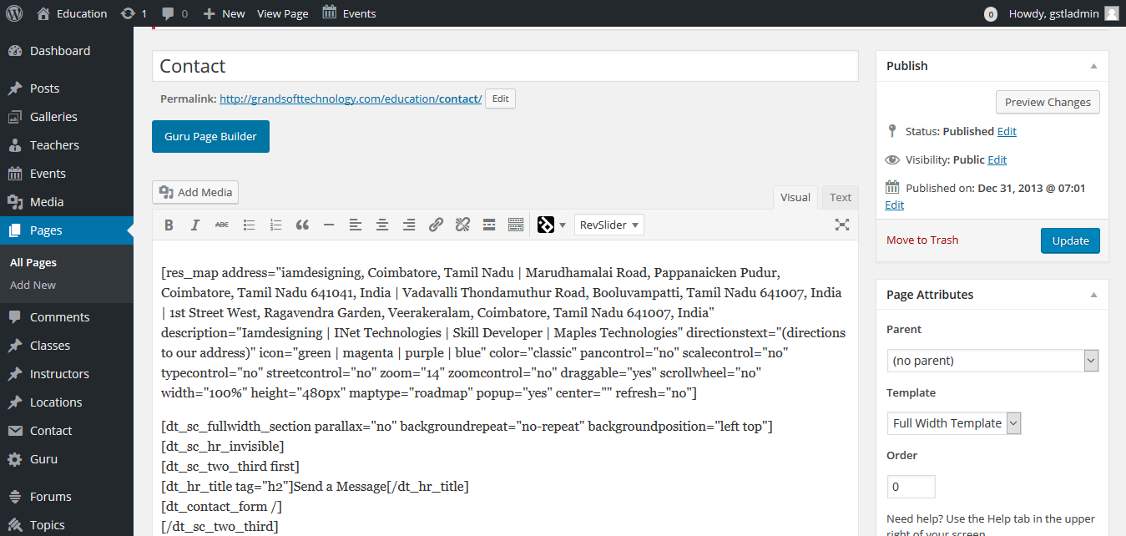

**END**